

Rosanna Cubs –
Victorian Scout Heritage Centre
Tuesday 25th May, 6:30pm

On Tuesday 25th May, we’ll be doing the 2nd part of our Local History Badge by attending the Victorian Scout Heritage Centre at Como, South Yarra.

While there we’ll get the chance to learn plenty about the history of Scouting worldwide and especially in Victoria.

Details:
- Meet at the Hall prior to 6:30pm, ready to leave at 6:30 pm sharp.
- Session at the Heritage Centre will be from 7-8:30pm
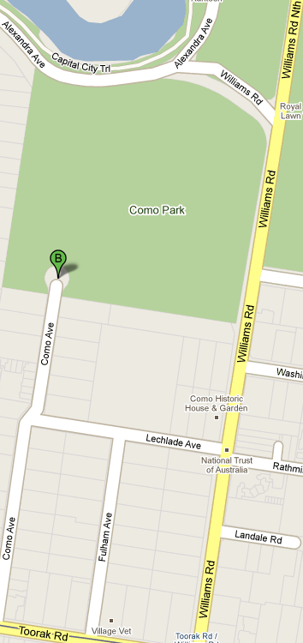
- Pickup from the Hall at around 8:50-9pm (approx).
- Cost is $2.50 (Cubs) or $3.50 (Adults)
- Some parents will be required for transport (due to capacity requirements at the Centre, we can only take those required for transport). Please notify Akela on arrival at the Hall if you’re able to provide transport if required.
While we’re meeting at the Hall, for the benefit of those providing transport, a map is shown here. The Centre is at the end of Como Ave, past the gates of the circular public carpark and off to the left.
Melway Ref: 58 G2

Akela
9434 7594
0411 121 495
akela@rosannacubs.org

